
Register Number

SRM INSTITUTE OF SCIENCE AND TECHNOLOGY
Set - B
SRM Nagar, Kattankulathur – 603203, Chengalpattu District, Tamil Nadu
College of Engineering and Technology
School of Computing
Department of Data Science and Business Systems
Academic Year: 2023-24 (Odd)

Test | : CLA-T1 | Date | : 11-08-2023
Course Code & Title | : 18CSE487T – Data warehousing and Its  Applications | Duration | : 50 Minutes (1 Period)
Year & Sem | : III&IV Year /V& VII Sem | Max Marks | : 25

Course Articulation Matrix:
S.No. | Course Outcome | PO1 | PO2 | PO3 | PO4 | PO5 | PO6 | PO7 | PO8 | PO9 | PO10 | PO11 | PO12 | PO13 | PO14 | PO15
1 | CO1 | 3 | - | - | - | - | - | - | - | - | - | - | - | - | - | -
2 | CO2 | 3 | - | - | - | - | - | - | - | - | - | - | - | - | - | -
3 | CO3 | 3 | - | - | - | - | - | - | - | - | - | - | - | - | - | -
4 | CO4 | 3 | - | - | - | - | - | - | - | - | - | - | - | - | - | -
5 | CO5 | 3 | - | - | 3 | - | - | - | - | - | - | - | - | - | - | -
6 | CO6 | 3 | - | - | - | - | - | - | - | - | - | - | - | - | - | -

Part – A
(5 x 1 = 5 Marks)
Instructions: Answer all
Q. No | Question | Marks | BL | CO | PO | PI Code
1 | What exactly is a data warehouse?  a. A database designed to handle transactions.  b. A database designed to support analytical reporting.  c. A database designed to support operational reporting.  d. A database designed to support transactional processing. | 1 | L1 | 1 | 1 | 1.3.1
2 | What is ETL?  a. Extract, Transform, Load.  b. Extract, Translate, Load.  c. Extract, Transfer, Load.  d. Extract, Transcribe, Load. | 1 | L2 | 1 | 1 | 4.2.2
3 | Difference between OLTP and OLAP.  a. OLTP is optimized for transaction processing, while OLAP is optimized for analytical processing.  b. OLTP is optimized for analytical processing, while OLAP is optimized for transaction processing.  c. OLTP and OLAP are the same thing.  d. OLTP and OLAP are both optimized for transaction processing. | 1 | L2 | 1 | 1 | 4.2.2
4 | What is a data mart?  a. A subset of a data warehouse that is designed for a specific business function or department.  b. A database designed to handle transactions.  c. A database designed to support analytical reporting.  d. A database designed to support operational reporting. | 1 | L2 | 1 | 1 | 1.3.1
5 | What is data mining?  a. A process for extracting information from data using statistical algorithms.  b. A process for integrating and cleaning data from multiple sources.  c. A process for querying and analyzing data in a data warehouse.  d. A process for transforming data into a usable format. | 1 | L1 | 1 | 1 | 1.3.1
Register Number

Set - B
Part – B
(2 x 10 = 20 Marks)
Instructions: Answer any Two Questions
6 | Explain in detail about the implementation of DataMart. | 10 | L3 | 1 | 1 | 4.2.2
7 | Explain in detail about DataMart and its types. | 10 | L3 | 1 | 1 | 1.3.1
8 | Explain Data warehouse architectures with their various components | 10 | L2 | 1 | 4 | 1.3.1

Course Outcome (CO) and Bloom’s level (BL) Coverage in Questions

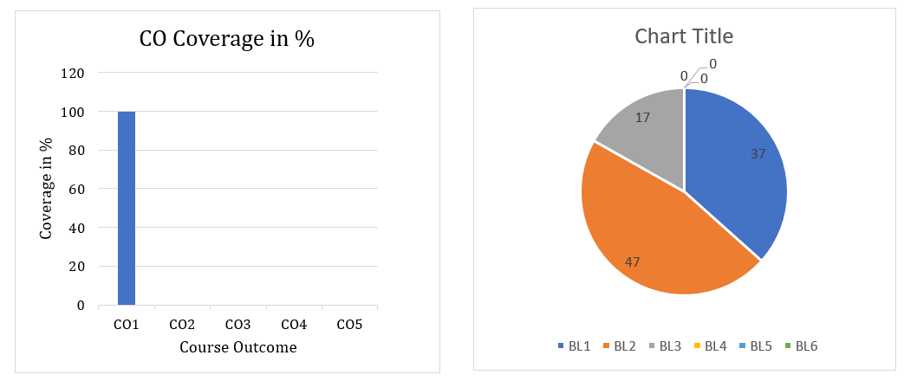

Approved by the Audit Professor/Course Coordinator

